A case study on the use of MOODLE databases as a means of maintaining e-portfolios for Secondary PGCE trainees at Liverpool Hope University
John Sharrock, Subject Leader, PGCE (Secondary) ICT, Liverpool Hope University

The ICT team at Liverpool Hope University was successful in bidding to take part in a pilot of MOODLE which will eventually replace Learnwise as the University VLE (Virtual Learning Environment). It has been used throughout the year 2007/8 with a group of 32 trainees on the PGCE Secondary course. This enabled the team to experiment with the greater range of electronic activity types available to support learning. Furthermore, these have been built into the course as part of the discussion of teaching strategies.

Of particular interest is the use of MOODLE for trainees to build their portfolios. The procedure for data/document collection has been refined and trainees are asked to submit various documents into databases accessible through MOODLE. These are designed so that each trainee can only see and edit his/her own data but the tutors can see all of the data.
In 2006/7 the Secondary ICT team experimented with electronic data management but without a proper system. It was clear even then that this was highly desirable compared to the paper chase of previous years. In 2007/8 the features of MOODLE were tested as a means of providing a solution. This has worked much more efficiently and effectively. There are still a number of trainees who have difficulty in providing timely data but the key point is that they deposit the data straight into a database which means that the tracking of it is much more straightforward. It is much easier for the staff to identify missing data. Also, as the students are making use of the database as a store, they themselves are able to see the usefulness and the ‘willingness to comply’ has gone up noticeably (27 out of 31 regularly provide key data required). In addition, the extent of the data being asked for has increased to include CV related data, QTS skills test status. Perhaps the most exciting aspect is a summary spreadsheet of lesson observation data which the trainees are being asked to maintain and upload. This is enabling easier tracking and the department expect to be able to complete analysis of the data to inform on issues such as consistency across schools, progress through the course, problem strands requiring development and Q standards being addressed.
A further benefit of this system is that it requires less work from the staff, enabling them to concentrate on the issues behind the data rather than being over faced by its collation. The data being uploaded is now looked at in more detail.
CV Database
The first screenshot below shows the introductory instructions and also the number of entries made at the time of writing. The second shows the individual entries made by one trainee. The trainees are guided as to what files should be put in this database but its name is intended to make that self evident. The author is not clear as yet how useful this has been for the trainees but it has been very useful when having to compile references. Note the simplicity of the structure – each entry is merely a file (with a less than intuitive naming convention!)
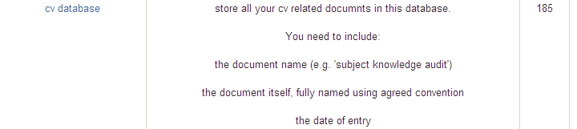

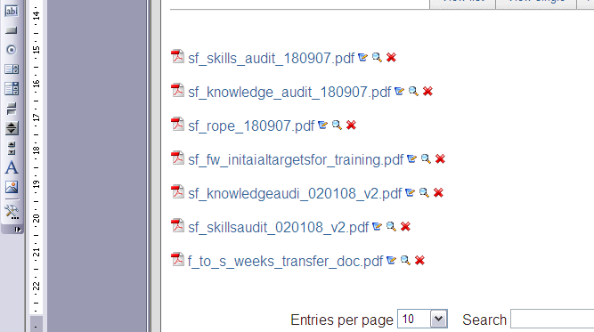

QTS Skills database

This is another self evident database in which the trainees simply record via a radio button their status regarding the tests. Whilst working well this database will probably not be stand alone next year as we will be looking to consolidate the use of the portfolio and include evidence for all standards of which this is, of course, just one.

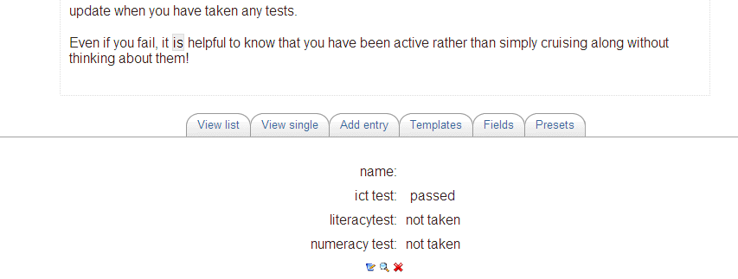

Timetable database

Again, this is obvious but also very useful as the staff need to consult timetables frequently to arrange visits.

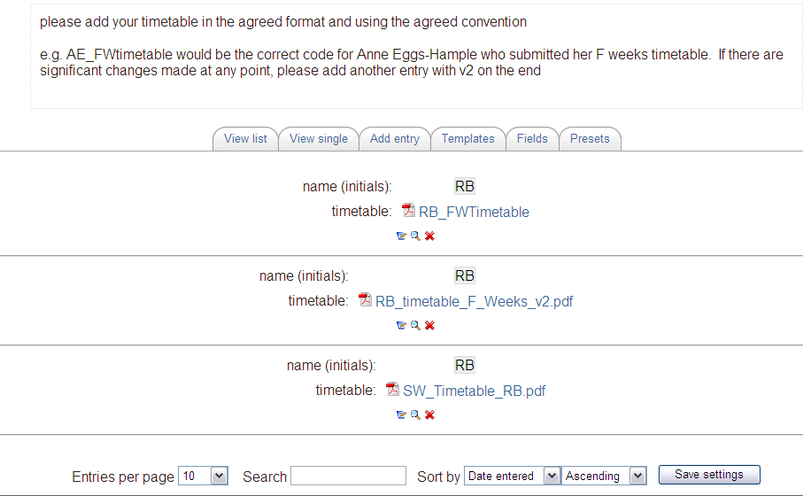

Review database

This is used to collect evidence of trainees’ progress against the standards. It is certainly very useful for staff to have access to and is needed for the records but trainees have found it time consuming because many of them rely on scanning paper copies rather than working electronically and these documents involve many pages. This is certainly an area for development.

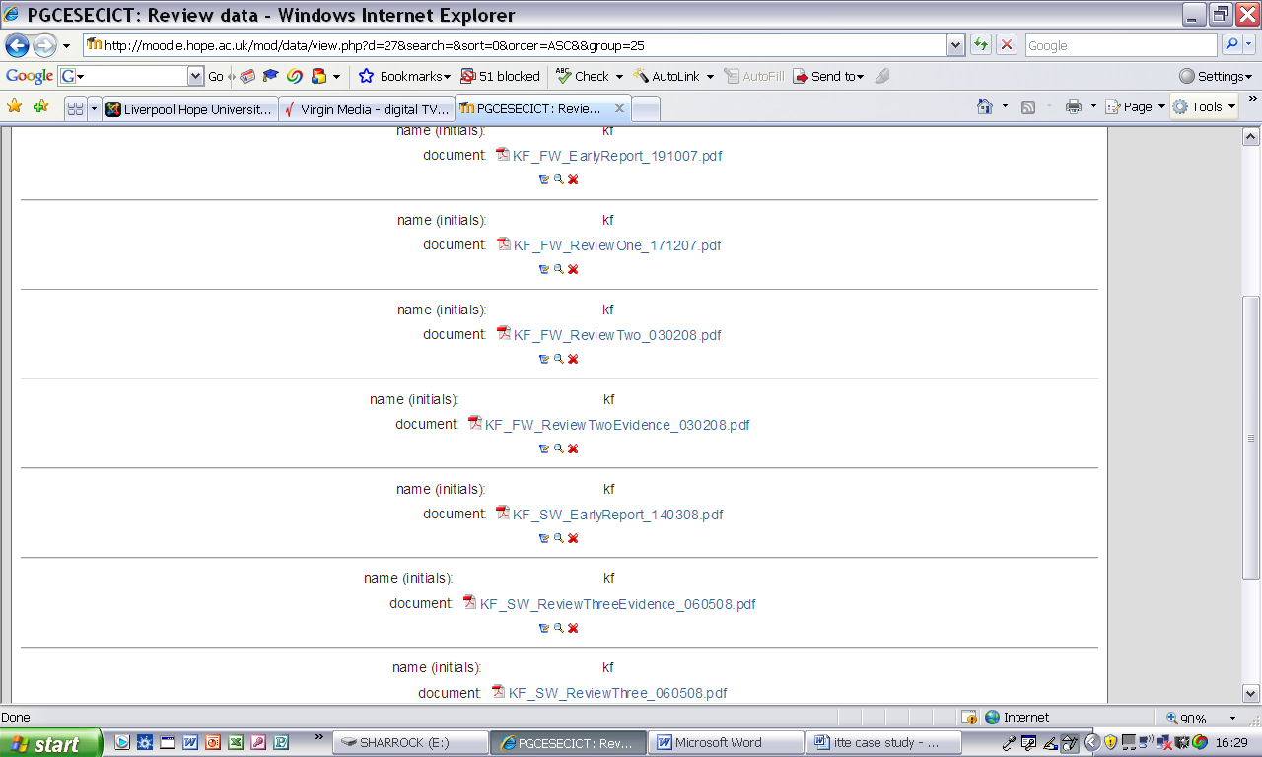

Lesson Observations

Formal lesson observations are stored together with a summary sheet which helps to spot trends. Of course, not all trainees upload at timely intervals but the same was true of previous systems. The point is that they are automatically stored and ordered without the need for any input from staff who are free to focus on how the trainees are progressing.

A summary sheet for one trainee is shown below. As an example, note that homework stands out as an issue. There is much potential in having this data available and the team intend to do some analysis of it on completion of the course this year.

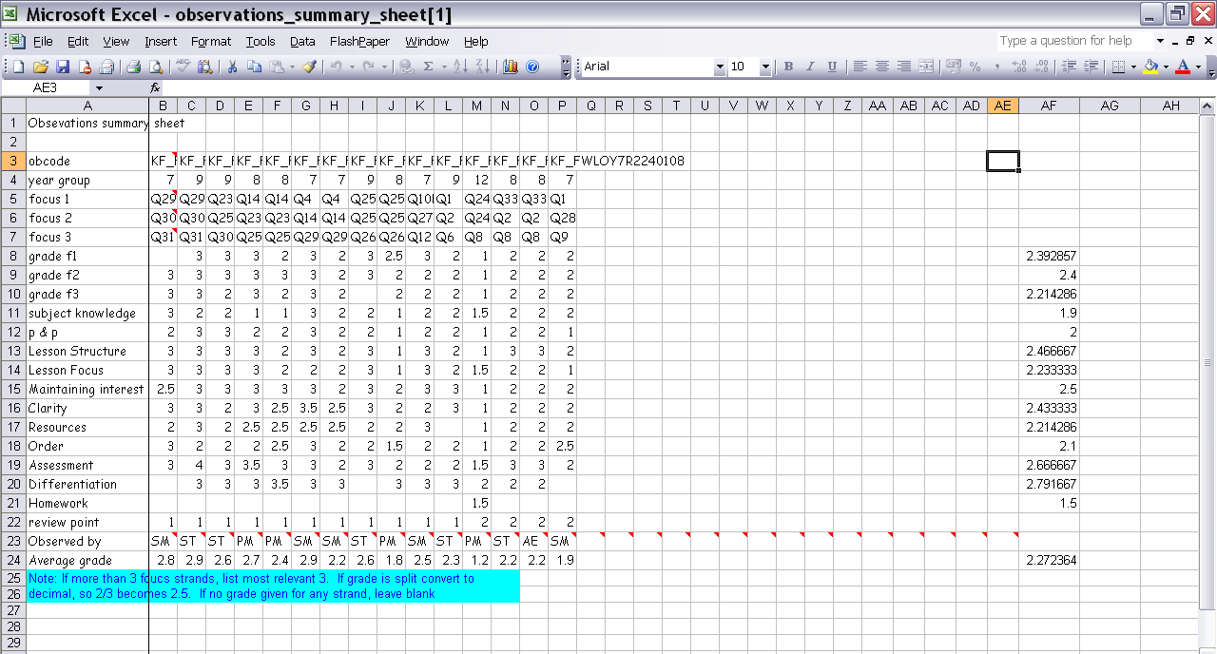

As should be apparent from the examples above, the data structures are generally simple but effective. The use of them has been of considerable benefit to staff and, to a lesser extent, the trainees (directly).

One fundamental issue to be aware of here is that MOODLE databases are not currently compatible with other databases. The data cannot be exported in a useful format. Our view is that it was still very much worthwhile but this is obviously a problem.

The team is considering moving away from the use of MOODLE to a more intuitive method. For instance, many of our trainees claim that they need practice in Web design skills and it would be worth considering allowing them to build their own portfolios in a web environment. This would give them greater freedom and control of the data but it would present problems of its own. For instance, the University would need to provide web space if the portfolios were to be accessible by staff. All in all, the simplicity of the MOODLE data solution makes it successful. Our current thinking is towards encouraging the trainees to create their own portfolios as suggested above which would get them working with an electronic mindset and thus make transferring data into MOODLE more seamless for them.

John Sharrock
Subject Leader, PGCE (Secondary) ICT
Liverpool Hope University
May 2008

